**Weather Assistant Bot**

# By Team INFINITE LOOP

# Team Members:

# Godwin

# Guru Prakash

# Lakshmi Narayanan

Stack Used : Nodejs,Socket io   
User Interface : HTML,CSS

We have hosted our project in <https://weather-bot-godwin.herokuapp.com/>

Input : Voice Input using Voice Recognition   
Output : Speech using Speech Synthesis and Text Output \

Requirement : build in Microphone and Speaker on your system

We have implemented a weather assistant bot that accepts the voice input using microphone and tells weather report of the any input place all over the world through speech

Currently we have implemented to the bot to speak only about the weather report and the next step will be the bot which has knowledge about everything and gives us the response as per and acts as the intelligent robot

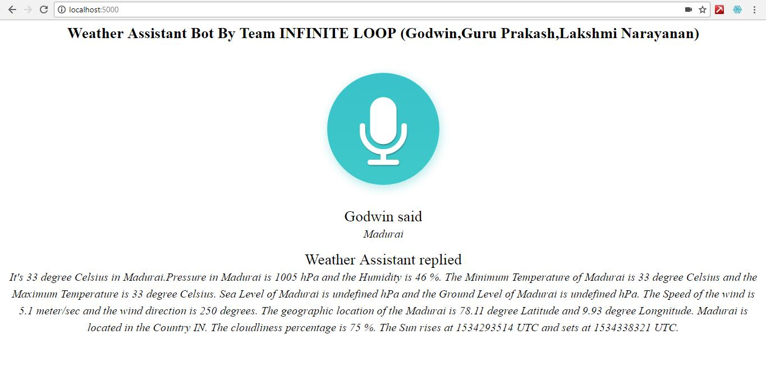

# Working

Initially onclicking on the button(Microphone icon) , the browser prompts you for enabling the microphone on your system , then the microphone starts listening to the voice input , Once the voice input(name of the city) is given , the voice input is converted into text using voice recognition and then posted to the api link along with my api key. Then the api request hits the server and returns back as a JSON response , I parsed the JSON response and formated it into a readable paragraph and send the result to the SpeechSynthesis which converts the Text into Speech , Finally the Output is given Speech and Weather Assistant Bot gets implemented.

The Next Step of implementation will be the Intelligent Robot that knows about everything , initially we have started with Weather Assistant Bot